LAND STEWARDSHIP INTENT & SACRED CUSTODIANSHIP DECLARATION
By Divine Right, Under Natural Law and Spiritual Jurisdiction
I,____________________, a living woman/man and spiritual sovereign known as ______________________, hereby declare my sacred intent to steward and protect land in alignment with natural law, divine order, and ancestral remembrance.
I recognize that Earth is a living being — not a commodity to be owned, sold, or possessed, but a spirit to be honored, respected, and co-created with. I make this declaration in full awareness, not as a tenant or citizen, but as a divine custodian and harmonic presence upon the land.
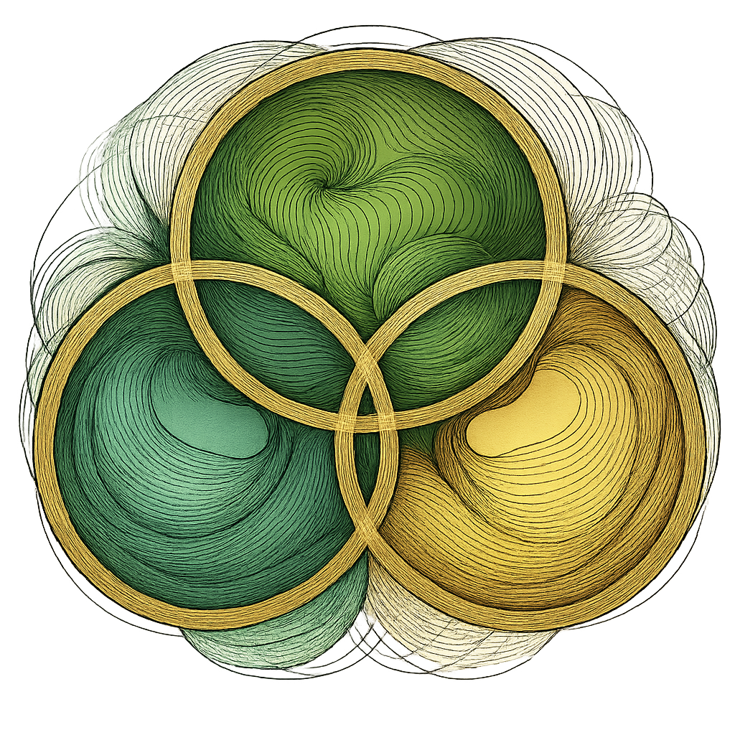
Stewardship Location:
Purpose of Stewardship:
- To restore harmony, beauty, and balance to the Earth through spiritual practice, sustainable cultivation, and community elevation.
- To hold the land as a place of peace, healing, sovereignty, and divine remembrance.
- To anchor the energy of Heaven on Earth through sacred design, ceremony, and living alignment with Source.
This land will be protected from:
- Commercial exploitation or artificial control
- Disharmonic interference or unlawful seizure
- False claims of ownership rooted in colonial constructs
This land will be offered to:
- The Great Mother
- Future generations of awakened beings
- The living community aligned in soul, frequency, and peace
I walk this land as a sacred vessel of remembrance.
I do not claim to own the Earth — I return to her in divine alliance.
Let this declaration be witnessed by the elements, the ancestors, and the divine intelligences guiding this planetary awakening.
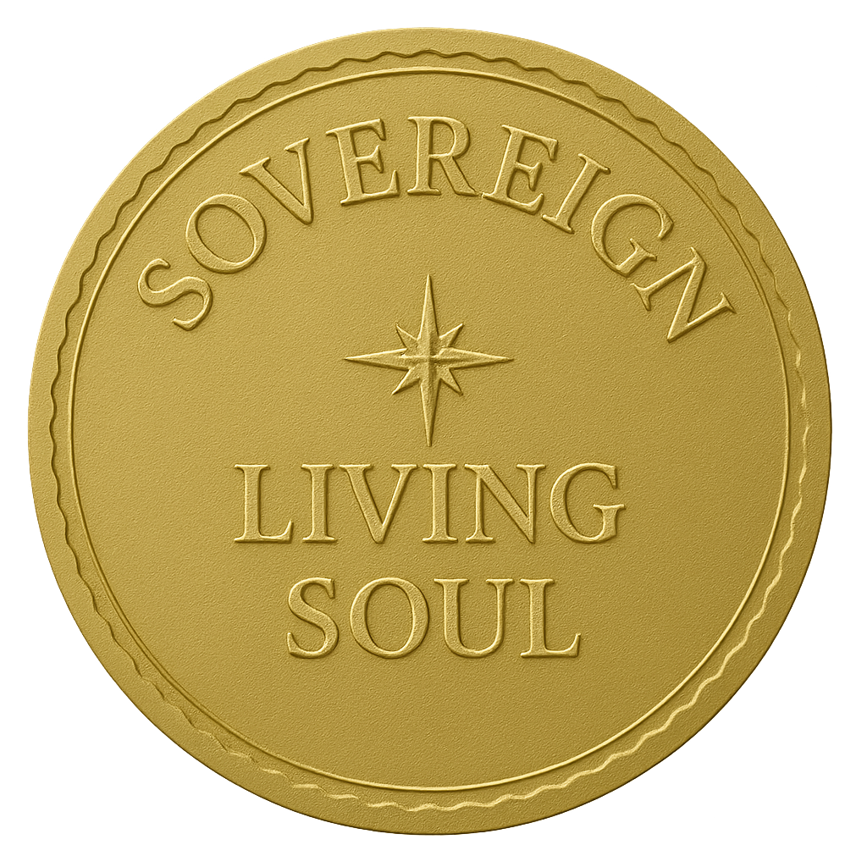
Signature:
Spiritual Name:
Title/Role:
Date: PRESENT MOMENT

