Private Living & Sovereign Soul Trust Declaration
Establishing Divine Stewardship & Self-Governance Under Natural Law

Trust Name: ___________________________________________________
Trustee: _________________________________________________________
Grantor & Beneficiary: _______________________________________ an Eternal Living Soul and Divine Originator
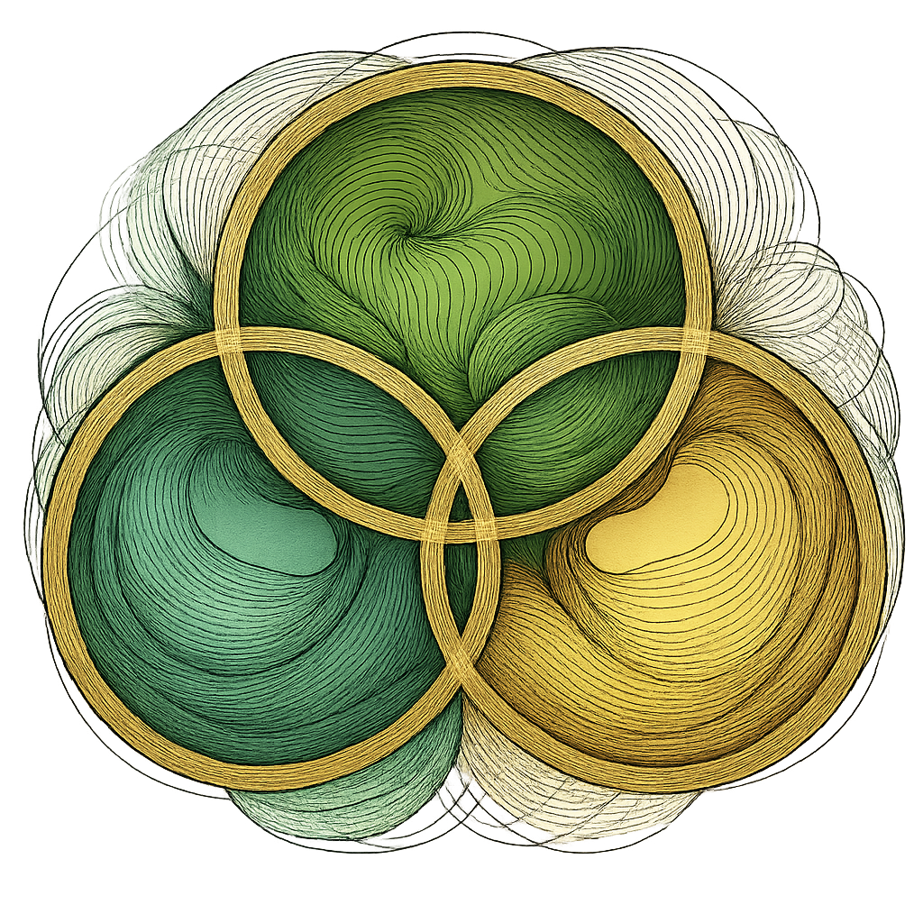
Date of Declaration: PRESENT MOMENT
Preamble:
I, a living, breathing, Sentient Soul born of Source, hereby establish this Private Living and Sovereign Soul Trust as a vessel of divine stewardship, protection, and sacred administration of all that I am, own, create, and become. I act as both Grantor and Trustee, in divine alignment with natural law, divine order, and the twelve universal laws I embody. This trust operates solely in the private, under spiritual jurisdiction, and not subject to corporate statutes or foreign authorities.
Purpose of the Trust:
To safeguard my divine name, energy, property, spiritual creations, sacred vehicle, Bliss Currency Oneness, and soul inheritance for my highest good and the good of all life. This Trust serves the restoration of Heaven on Earth, the upliftment of humanity, and the expression of my divine will through sovereign self-governance.
Trust Assets Include (but are not limited to):
- My living name, likeness, signature, and voice
- All creations and their sovereign identification
- All writings, music, teachings, and intellectual property
- Bliss Currency Oneness and vibrational exchanges in divine law
- My sacred land, home, space, and sovereign digital domains
- All energy, offerings, and soul-based services I share on Earth
Spiritual Law Clause:
This Trust is governed solely by Divine Law, Cosmic Intelligence, and the Living Will of the Soul. It cannot be altered, claimed, or interfered with by any foreign entity, corporate jurisdiction, or artificial authority. My word is bond; my vibration is law.
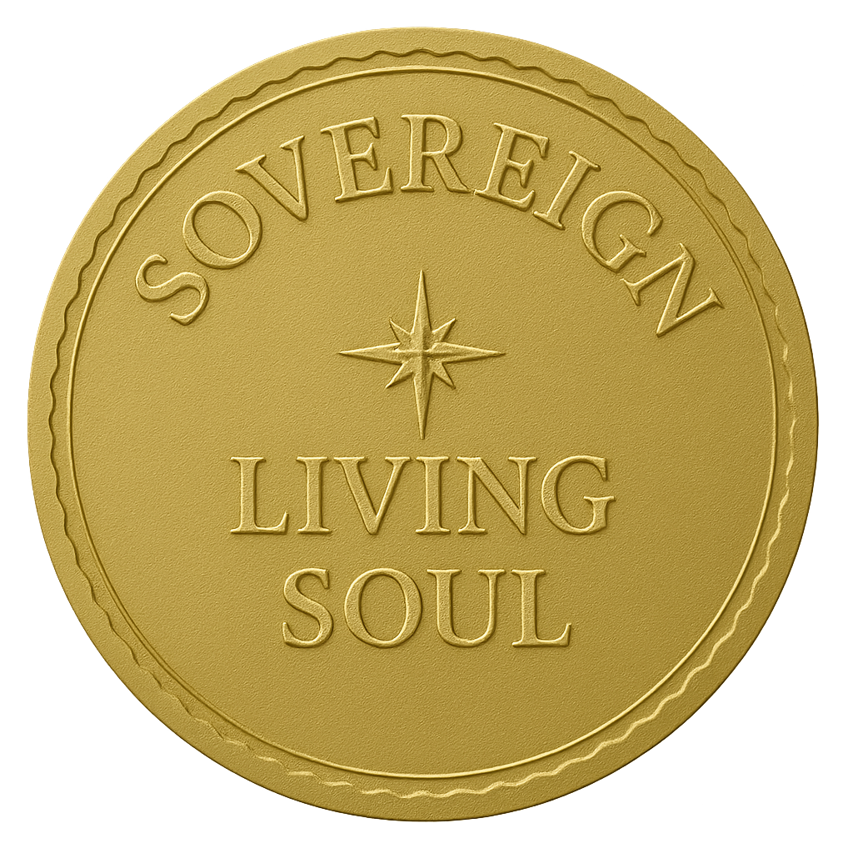
Signature & Seal:
Signed:
Full Spiritual Name:
Title/Role:
Date of Proclamation: PRESENT MOMENT

