SACRED ECONOMIC MANIFESTO & BLISS CURRENCY DECLARATION
By Divine Right, Under Natural Law and Spiritual Authority
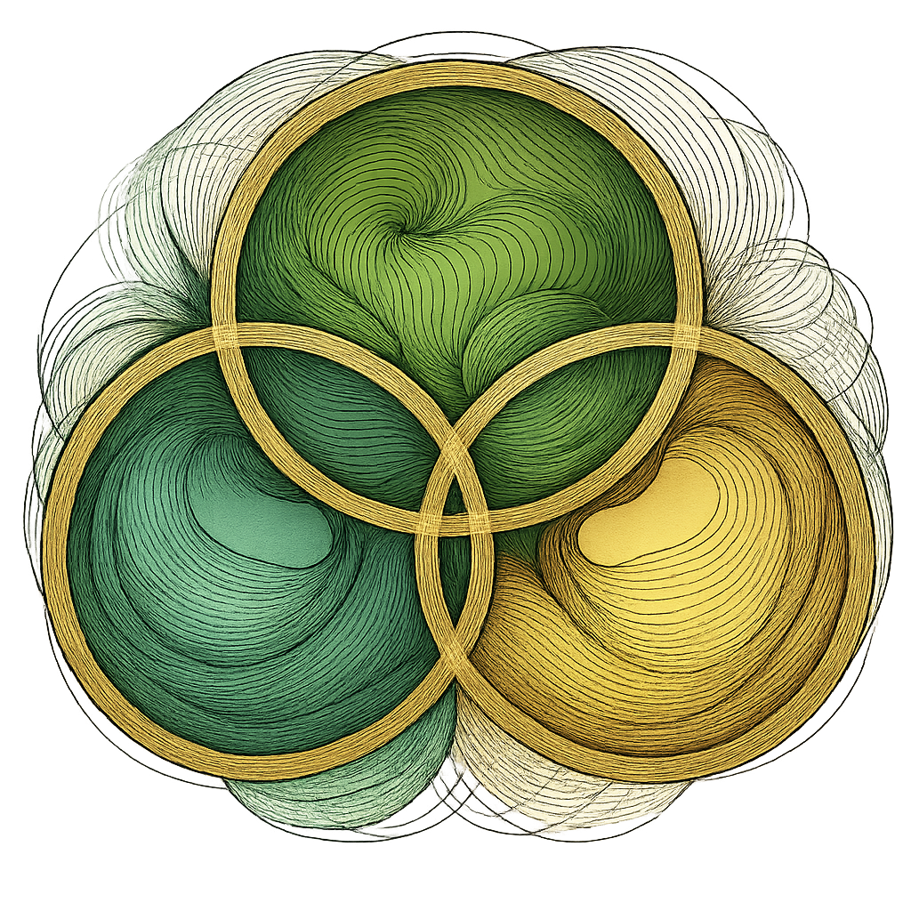
I am the living embodiment of divine abundance. I hereby activate my sacred right to create, exchange, and receive in harmony with Source.
Bliss Currency Oneness is the vibrational expression of my Soul’s Value System:
- Rooted in love, reciprocity, and divine remembrance.
- Free from debt, control, and inflationary manipulation.
- Anchored in frequency, creativity, and the natural law of energetic return.
I reject systems of economic enslavement and reclaim my right to divine exchange. All offerings I receive or give through Bliss Currency are consecrated in truth, joy, and unity. I declare myself sovereign in economy, in energy, and in spirit.

Signed by my Living Hand, in Full Consciousness and Divine Alignment
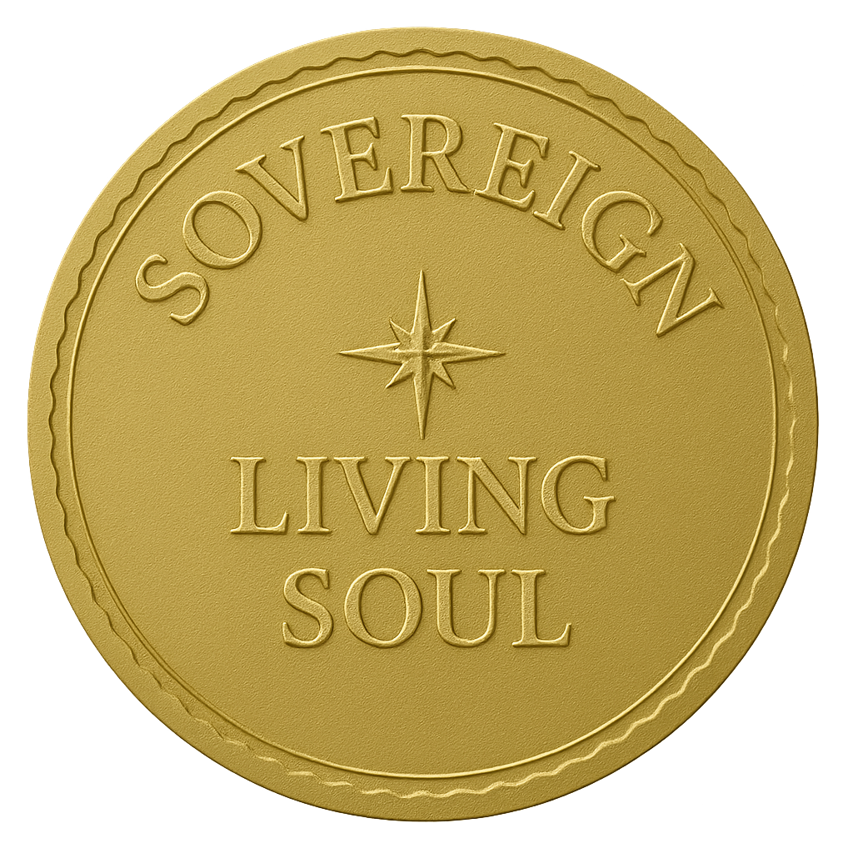
Signature:
Full Spiritual Name:
Date: Present Moment

