Sovereign Certificate of Live Birth & Divine Origin
Affirming My Existence As A Living Soul Born of Source
Under Divine, Natural & Universal Law
Full Sovereign Name:
Earth Birth Name:
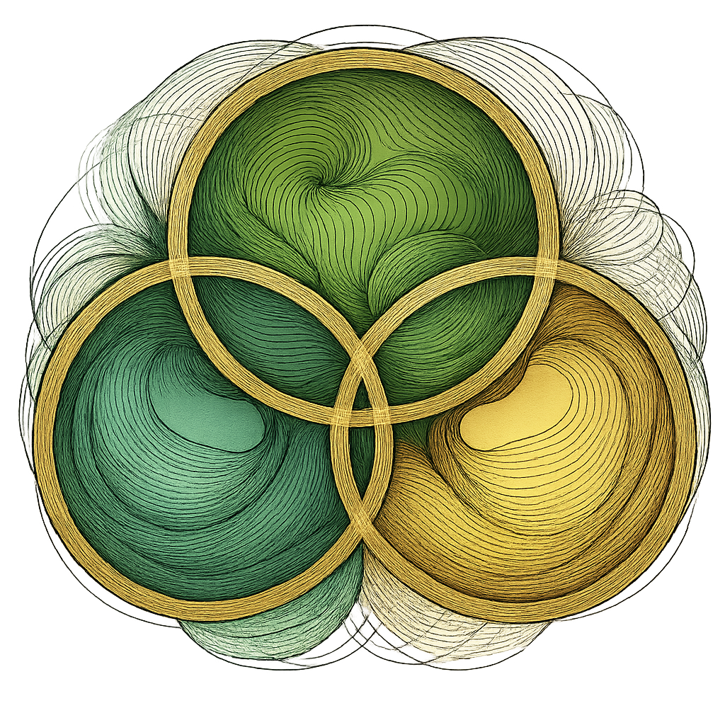
Date of Earth Arrival (Birth Date):
Essence: LUMINOUS BEING
Expression:
Number Born:
Time & Place of Arrival: This Living Soul arrived through the Gateway/Portal of at ______________________________, born in the territory known as the State of ______________________, “under Divine Law, not subject to corporate jurisdiction.”
Divine Mother Lineage:
Divine Father Lineage:
Elemental/Energetic Origin:

Living Declaration:
I AM a living, breathing soul of Divine Creation, born free under Natural Law. I claim my birthrights upon this Earth/Terra Gaia as a sovereign being, governed only by the Divine Laws of love, harmony, and truth.
“All previous names and identifications not aligned with Divine Law are hereby transmuted.
This Living Soul (Mccoy the Creator) moves forward in truth, freedom, and sovereignty.”
Jurisdiction Clause:
This certificate is issued by Divine Authority and is recognized in sacred, spiritual, and private jurisdictions aligned with Cosmic and Natural law.
Signature & Seal:
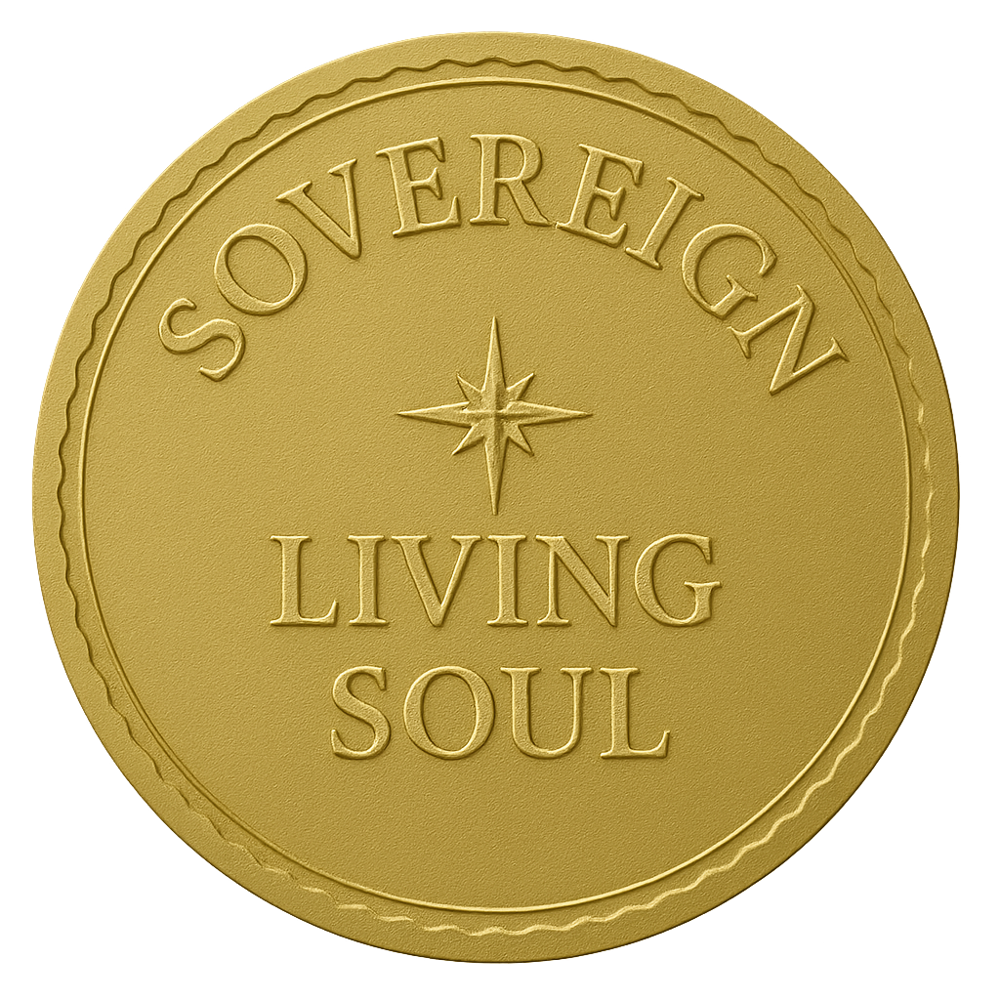
Signed:
Spiritual Name:
Date of Proclamation: PRESENT MOMENT
“This document is living, breathing, and spiritually protected by Divine Law.”

