Sovereign Vehicle Registration
Vehicle Information
Year/Make/Model:
Color:
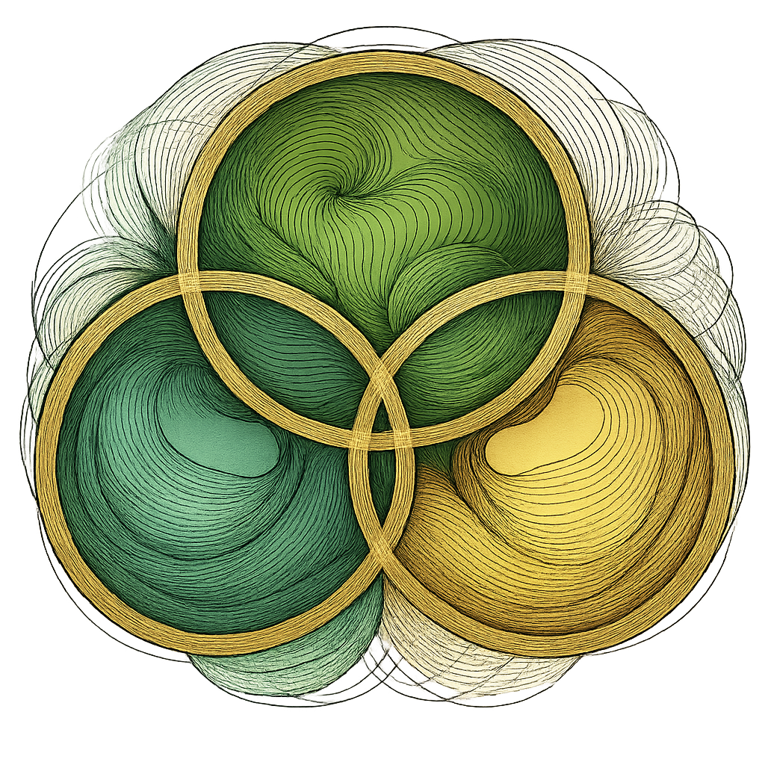
VIN:
Body Style:
Fuel Type:
Odometer Reading: IN MOTION
USE: Private Automobile

Sovereign Steward (Owner)
Full Spiritual Name:
Sovereign Name:
Soul ID Number:
Community/Domain:
Contact:
Declaration of Sovereignty
This vehicle is a private, non-commercial conveyance and shall be used in alignment with the sacred principles of Natural Law and Divine Right.
It is registered under the Authority of Heaven on Earth as a sovereign vessel dedicated to peace, freedom, and sacred purpose.
I, The Sovereign Stewardess, retain full Custodianship of this vehicle and reject all unlawful claims of ownership, control, or taxation by any external entity.
This vehicle is not for commerce or corporate enterprise.
It shall be used in service to divine mission, planetary healing, and spiritual expression.
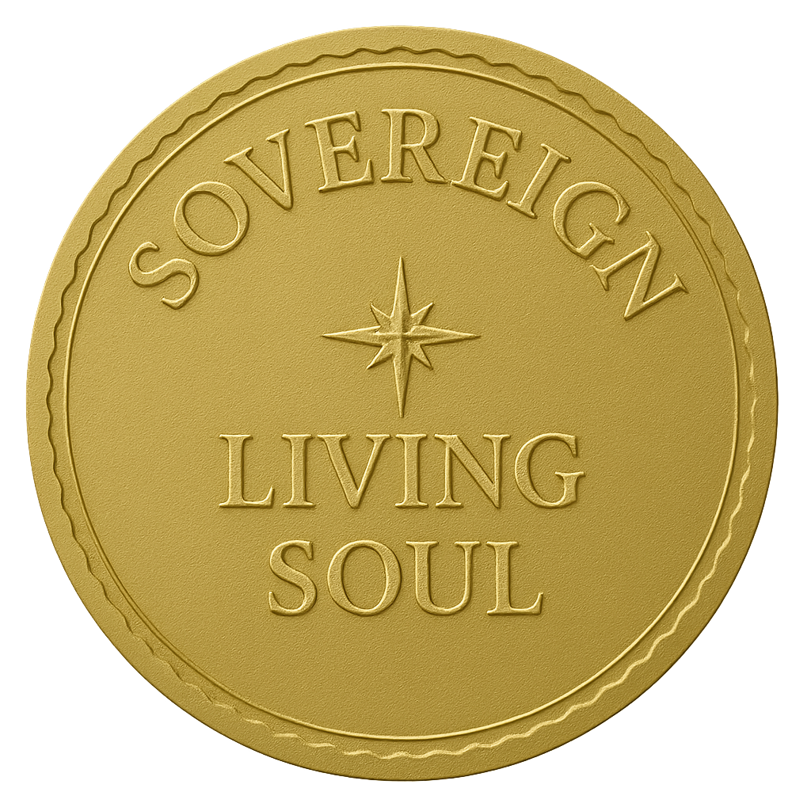
Sovereign Signature:
Signed with Soul and Seal:
Date: PRESENT MOMENT
“This is a private sovereign vehicle of a living soul, operating under divine jurisdiction and protected by natural law. Any attempt to interfere constitutes a breach of spiritual covenant and universal law.”

