The Twelve Universal Laws
A Sacred Guide to Living in Harmony with Divine Order
Law of Divine Oneness
🌐 Everything is connected. Every thought, action, and being affects the whole. When you harm or heal one part, you affect the entire web of existence.
Law of Vibration
🎵 Everything is energy and vibrates at a unique frequency. Your thoughts, emotions, and intentions emit frequencies. You attract what matches your vibration.
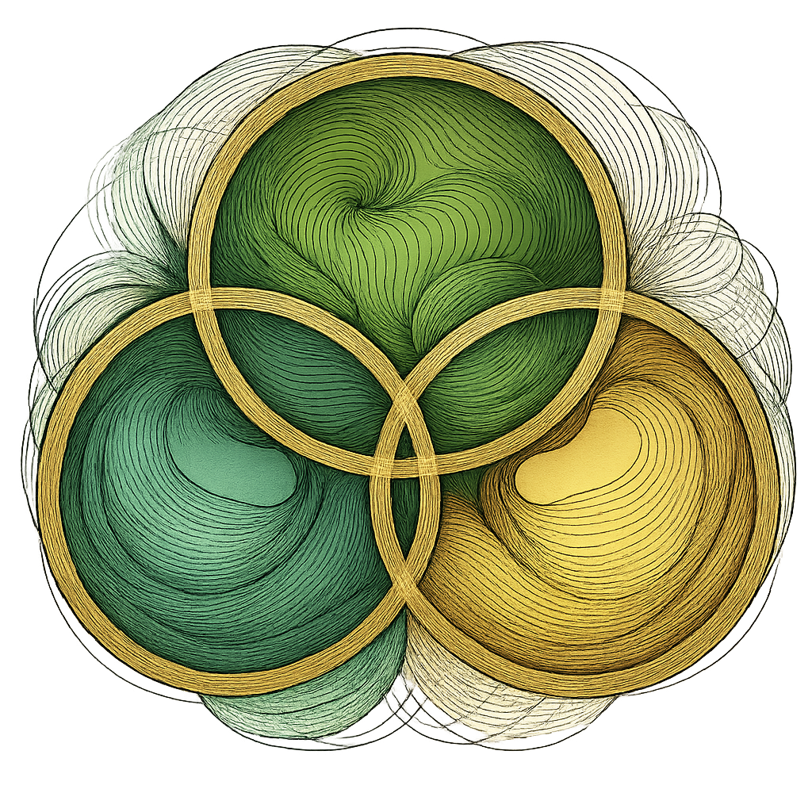
Law of Correspondence
🪞 “As above, so below. As within, so without.” Your outer world reflects your inner world. Transform within to shift what appears without.
Law of Attraction
🌟 Like attracts like. You magnetize experiences based on what you believe, feel, and focus on.
Focus on what you desire — not what you fear.
Law of Inspired Action
🚀 Manifestation requires movement. Align action with intention. Trust divine timing, but take soul-guided steps.
Law of Perpetual Transmutation of Energy
🔥 Energy is always moving and changing form with intention. You have the power to transform lower vibrations into higher ones— within yourself and in the world.
Law of Cause and Effect (Karma)
⚖️ Every action has a reaction. What you put out returns to you. Your choices ripple outward. Nothing is random — all is rooted in energetic causality.
Law of Compensation
💎 The universe balances the scales. You are rewarded in alignment with your contribution, effort, and vibration.
You receive in proportion to what you give —seen or unseen, spoken or silent.
Law of Relativity
☯ Nothing is good or bad until it’s compared. Everything is relative and meant to help you gain perspective and grow. Challenges offer contrast and growth.
Law of Polarity
🌓 Everything has an opposite: light and dark, up and down. Opposites are part of the same whole. Each has value in divine balance. Each extreme defines the other. Wholeness includes both.
Law of Rhythm
🌀 Life flows in cycles and seasons. Honor the timing of your soul's journey. There is a divine pulse to everything.
Ride the rhythm instead of resisting change.
Law of Gender
⚜️ Masculine and feminine energies exist in all. Balance brings creation and harmony. Harmony arises when the masculine and feminine energies are balanced: action and intuition, logic and emotion, giving and receiving.

